Group 4: Reciprocating Compressor

Mech 203 Project Report



## Introduction

Our project was to model a reciprocating compressor. Reciprocating compressors are one of the oldest compressor types and they are generally being used in refrigerators. The one we chose belongs to an Arçelik refrigerator. The working principle of a reciprocating compressor is similar to an internal combustion engine. In this compressor, as the piston goes back and forward, the refrigerant is sucked into the chamber, compressed, and distributed to the refrigerator by tubes. This cycle repeats itself as long as the compressor is working. These reciprocating compressors are really common in use. Nowadays some energy-efficient types of these reciprocating compressors are being produced (David). These compressors contain a lot of parts, are complex, and are sealed by welding, thus once they get damaged it is impossible to repair them. The compressor we used weighs 3.7 kilograms. The compressor works in between 1300 and 4500 rpm range and requires 220 Volt potential while working. It works with refrigerant R600a.

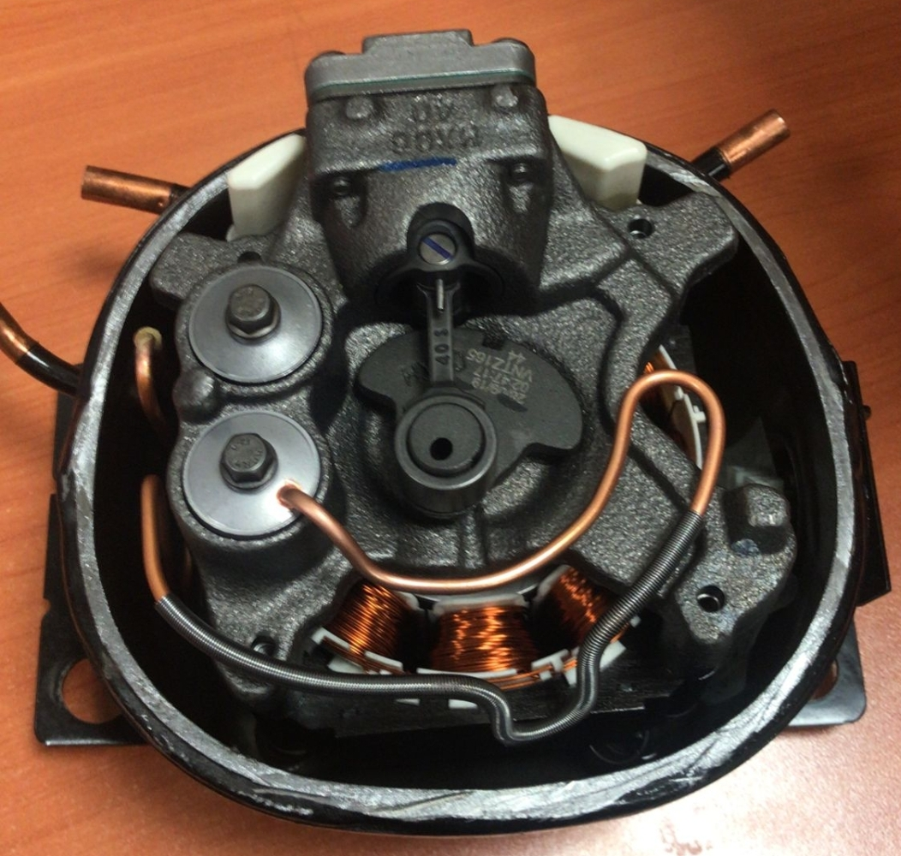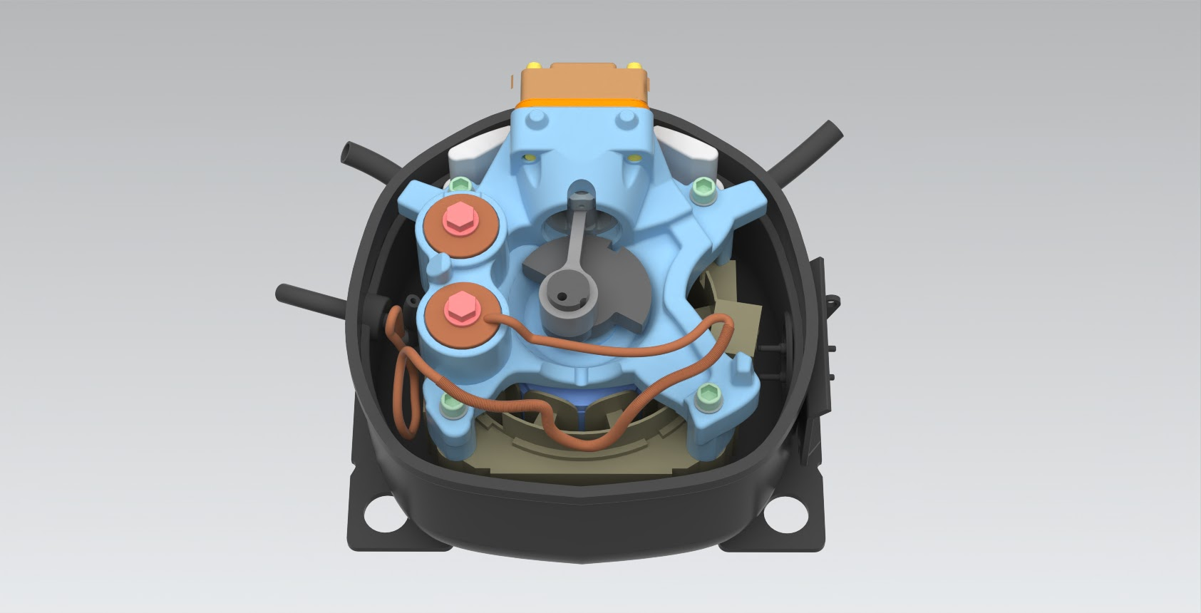

## Disassembly

How did you measure the dimensions of your part? Did you face any challenges during the disassembly or measuring the dimensions? How did you solve those problems?

We, most of the time, used a digital caliper; however, when the parts were particularly big or small we used other methods. For the big parts, when the caliper length wasn’t enough to measure; we used a ruler and for the very small parts we used our phone cameras to scale the smaller parts and have greater precision. One particular challenge was that we couldn’t rip the upper cap of the rotor therefore we lifted only a portion of the cap and extrapolated the inside magnet pattern. Another disassembly challenge was that some of the pins were force-fit so we had to exert great force on the pin to take it out. We also utilized the Engineering workshop and Mr. Muzaffer’s help in order to cut the housing and disassembly of the force-fit crankshaft.

|  |  |
| --- | --- |
|  |  |
|  |  |

## Exploded View

How many separate parts does your object contain? How many parts did you assemble in the assembly file?

We have 26 unique parts but with the subassemblies, the number goes up to 35 unique parts. The number of total parts is 46 and the breakdown of the parts is on the right.

Although the exploded view on the bottom is missing a few parts such as the screws that are numbered by 9 and 10, we fixed it in the real assembly file. The final version consists of all the parts that we’ve modeled.

|  |  |
| --- | --- |
| The top part of the assembly | The bottom part of the assembly |

## 

|  |
| --- |
| The middle part of the assembly |

## Part Comparisons

## Show only a couple of your important parts or sub-assemblies. Talk about some of the different commands you have used while creating the part or constraints in your sub-assemblies.

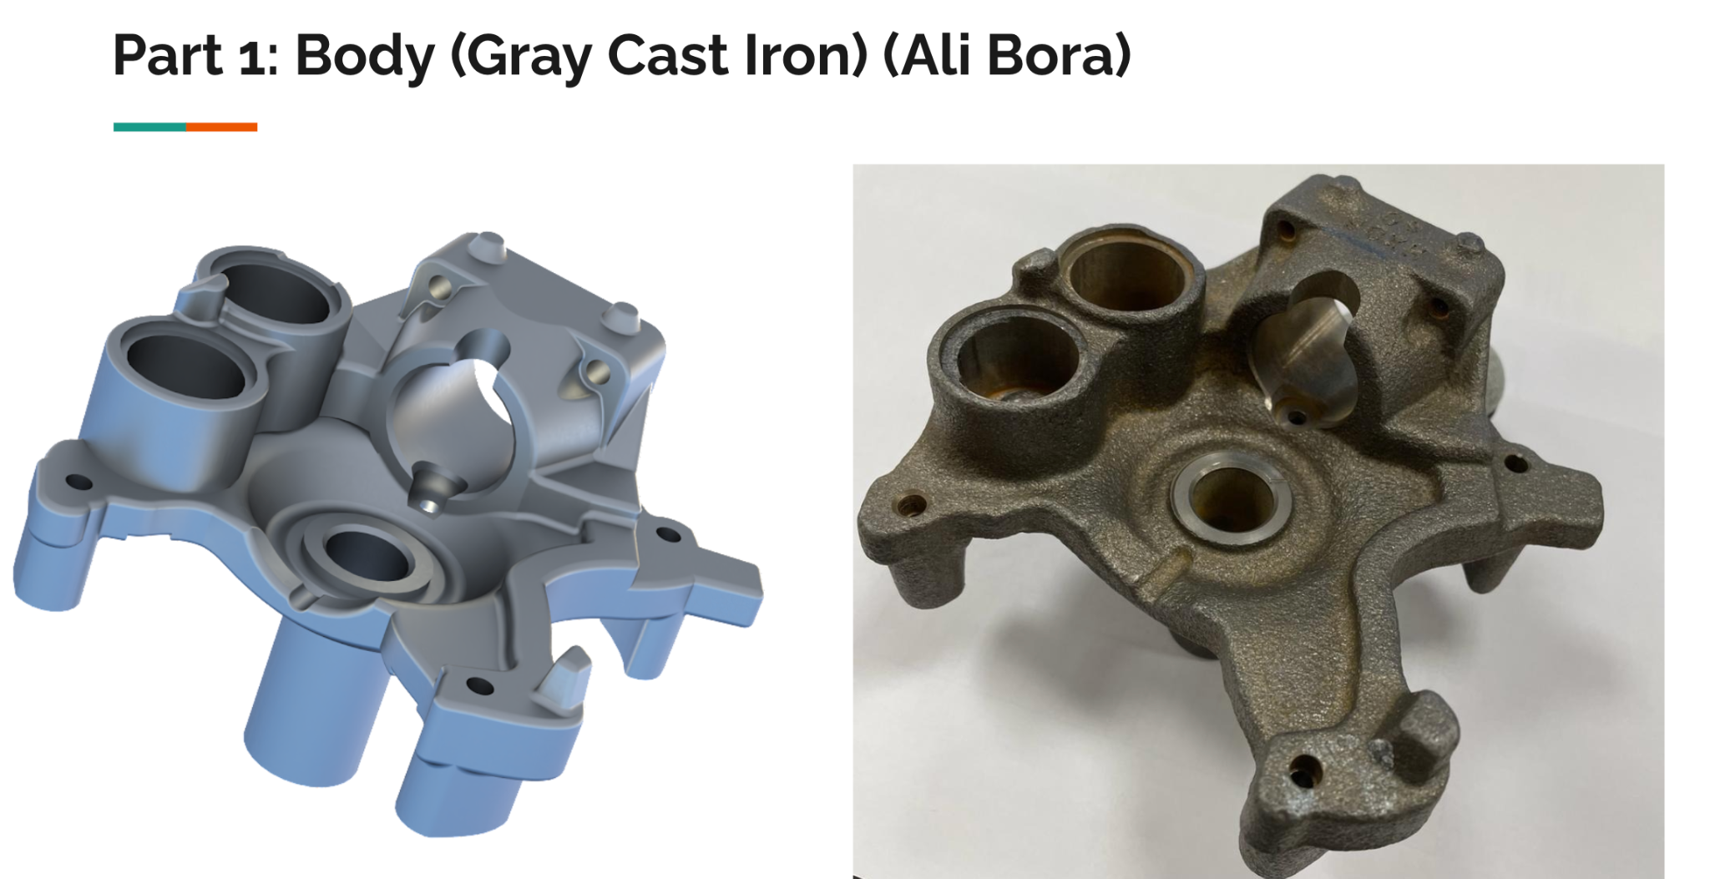

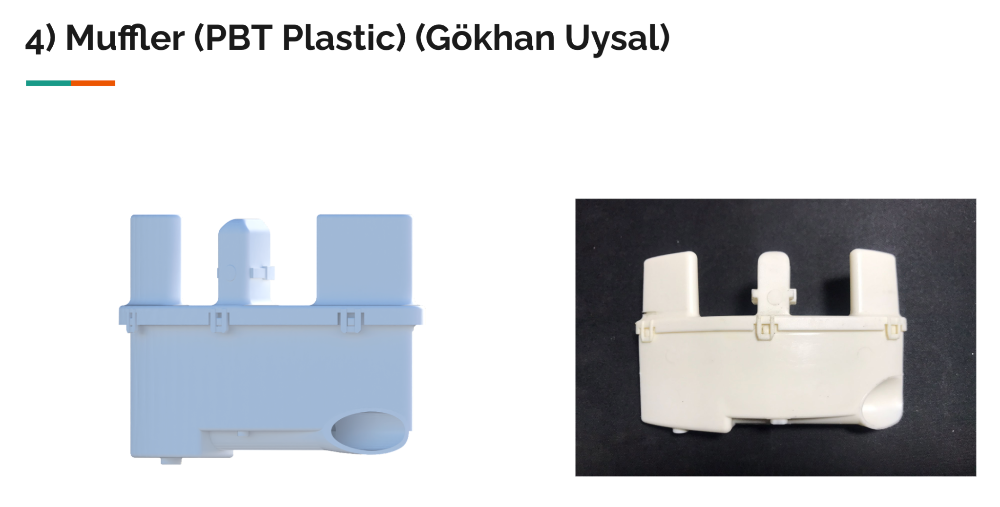

## 

## NX Commands

You can talk about extra features you have used here.

Some of the new features that we’ve learned are as follows:

* Sheet Metal Model and its features
* Spline
* Sweep Along Guide
* Text
* X-form
* Helix
* Thread
* Swept

**Helix & Sweep Along Guide:**

|  |  |
| --- | --- |
|  |  |

The **Helix** function has some parameters related to the properties of the geometry of the spring. After performing the helix function with proper parameters, a 1D string occurs and we have to follow this up with a 2D drawing. A datum plane is placed on the tip of the helix and a circle is drawn to that plane. Afterward, the **Sweep Along Guide** command was used by selecting the circle and the helix line, and the spring was formed. Sweep Along Guide command was also used in the pipes of the bottom housing with the help of Studio Spline.

|  |  |
| --- | --- |
|  |  |

**Sheet metal model** is a toolset in Siemens NX that allows you to design parts that will be manufactured by using sheet metal in a more convenient way than the conventional modeling tool. While the sketching function is the same as the conventional modeling tool, sheet metal modeling has functions like **bend**, **normal cutout**, **flange**, etc that mimic how sheet metal parts are usually produced so that the designer can design the part by keeping those aspects and the material in mind. For this part, the sketch of the part has been drawn as if the part had no angles when looked at from above. Then we used the **tab** function to create a piece of sheet metal of uniform thickness. Then we sketched the axes of bending on the object and used the bend command to bend the part in the places we wanted with the desired angles.

## Drafting and Tolerances

Talk about why the drafting for your chosen part is important. What surface and dimensional tolerances have you assigned and why?

Following is the drafting of the piston of the compressor. It was important to draft this part because it is one of the most sensitive parts in the assembly when it comes to its geometry. If some dimension of this part is inaccurately manufactured, the system will not operate properly, either converting the rotational motion of the crank inefficiently or leaking refrigerant, or not compressing the refrigerant properly or all of them.

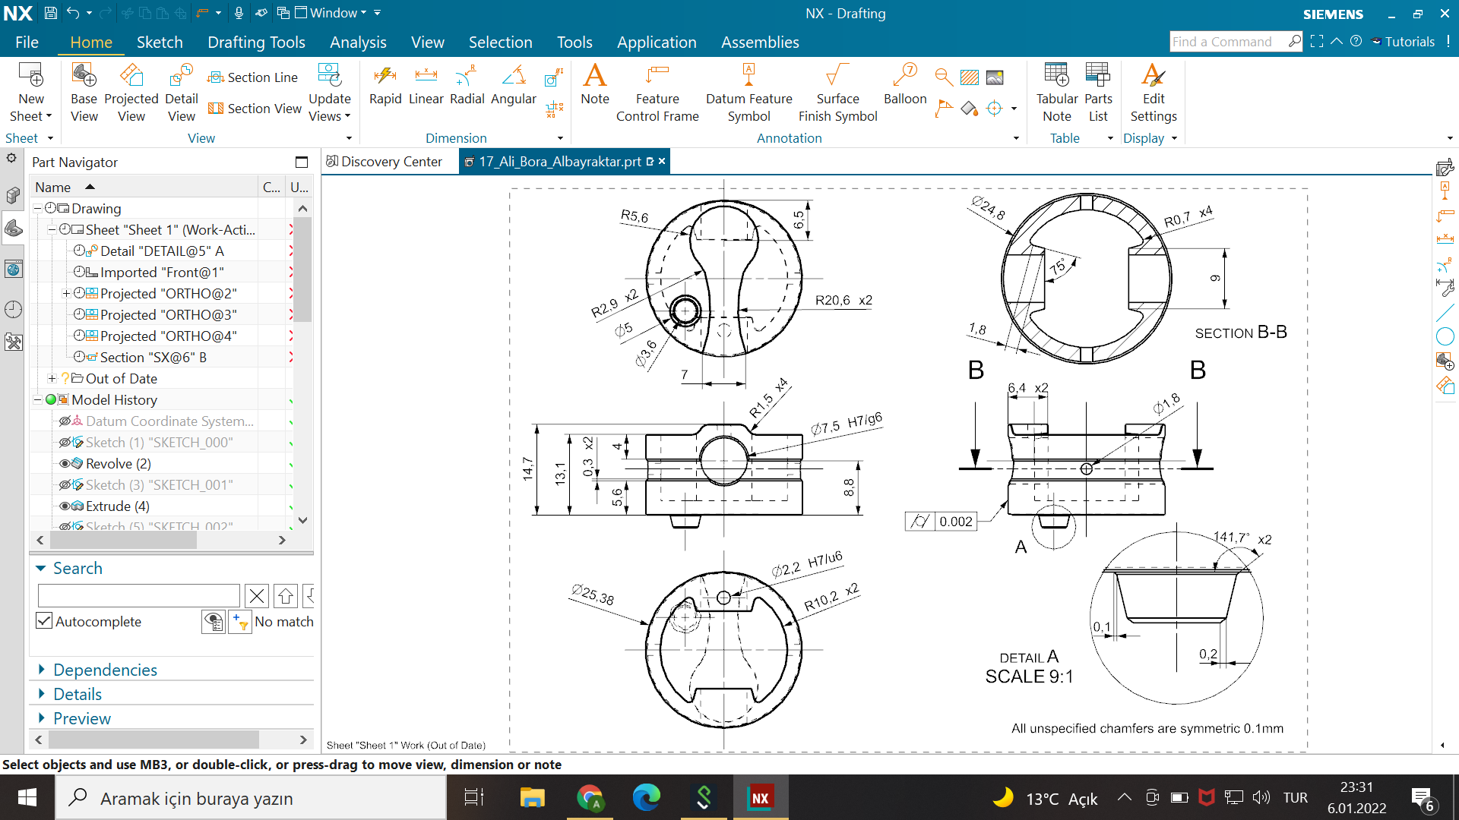

On the view on the middle left, we assigned a sliding fit tolerance of H7/g6 to the large hole in which the cylinder which will connect the piston to the connecting rod will fit because we want this part to slide freely to facilitate the conversion of rotational motion of the crank to linear motion of the piston.

On the view on the bottom left, we assigned a forced fit tolerance of H7/u6 to the small hole in which the small pin that fixes the aforementioned cylinder to the piston. We chose this tolerance because it was very hard to get this part out of its place by force, and it had to be a forced fit to keep the two parts together steadily.

The piston needs to be loose enough to move freely and tight enough to not have any leaks. It also needs to have an accurate cylindrical shape to have the aforementioned functions properly. Thus the piston’s outermost perimeter has a very small cylindricity tolerance of 0.002.

## Finite Element Analysis

Talk about one finite element analysis you have conducted. What did you simulate? Why is this simulation important? Which type of simulation have you conducted? (structural, fluid, heat…) What materials did you assign? What are the initial conditions? (How did you fix it? How much loading on where?) What does that result tell you? (Where do the stresses accumulate? Where can it break?)

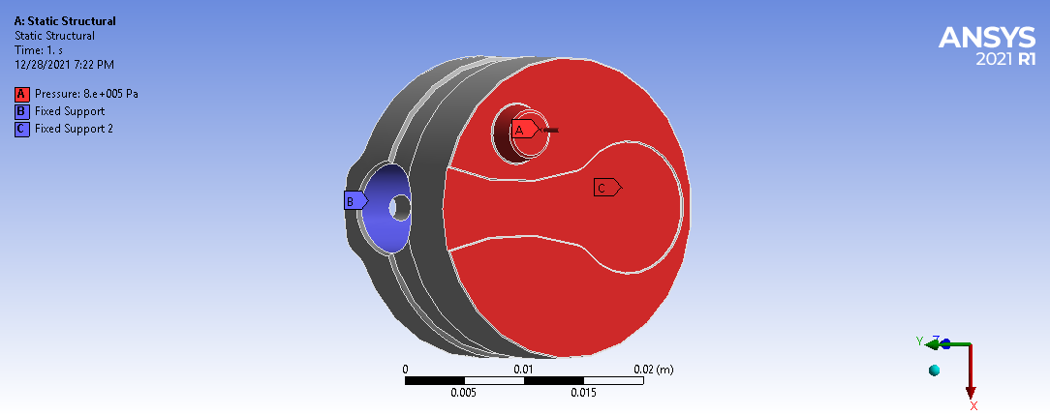

image 1.1

Finite Element Analysis of stress on the piston was conducted. Gray cast iron material was assigned to the piston. Fixed support was applied to the holes where the pin connects (represented by the blue color image 1.1). On the bottom surface of the piston, 8 bar (0.8 MPa) pressure was applied (represented by red color image 1.1). The piston meshed with an element size of 10-3 meters. 54148 nodes and 34231 elements were used in the meshing process. As a result, the maximum equivalent (von Mises) stress was obtained as 11.142 MPa. This result indicates that the piston is safe under 8 bar pressure because under 8 bar pressure, 11.142 MPa equivalent stress was obtained which is below the ultimate tensile strength that is 240 MPa. The piston starts to break from the inside of the front hole because as shown in image 1.2 the maximum stress occurred there.

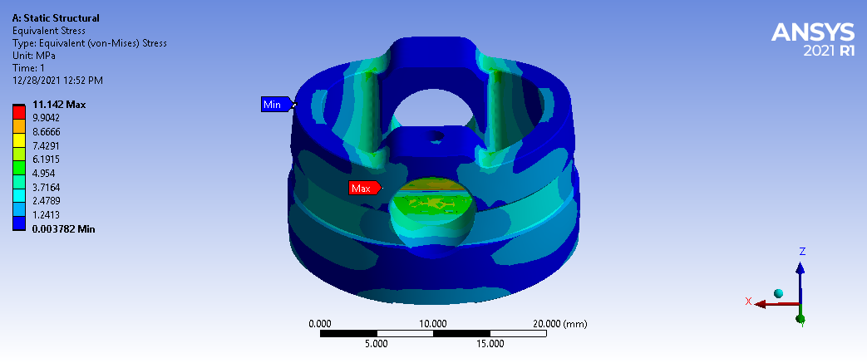

image 1.2

## Conclusion

We had a lot of challenging parts to measure and draw, thus we had to resort to creative ways to draw them. We learned many commands on NX such as helix, sweep along guide, sheet metal model, etc. As future engineers, we experienced teamwork and hands-on learning experience when it comes to disassembly. We planned the project and tried to distribute work evenly but we had some complications with some group members. We added time management skills to our skillset to complete our project before the deadline.

## Works Cited:

David. “Which Type of Commercial Refrigeration Compressor Is Right for You?” Compressors Unlimited / Reciprocating Compressors, 2018, https://www.compressorsunlimited.com/blog/which-type-of-commercial-refrigeration-compressor-is-right-for-you. Accessed 27 Jan. 2021.